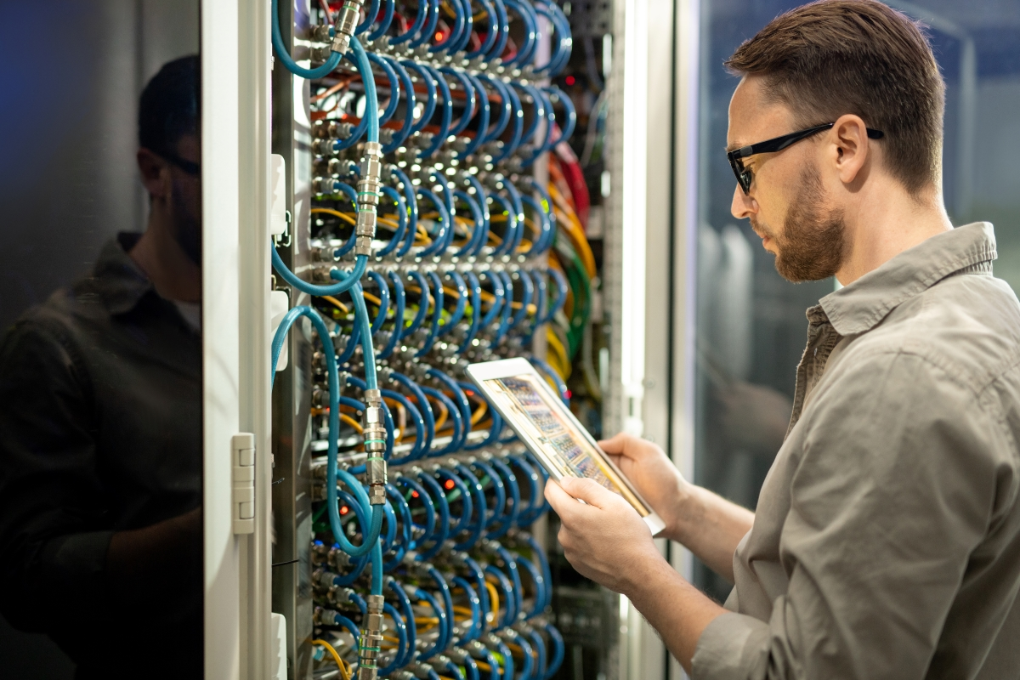

Helping Infrastructure Teams Build Smarter Data Centers

We at RackTrack building Al-powered solutions that transform rack images into accurate, actionable inventory, enabling organizations to simplify operations, improve asset visibility, and manage their infrastructure with confidence.

RackTrack at Glance
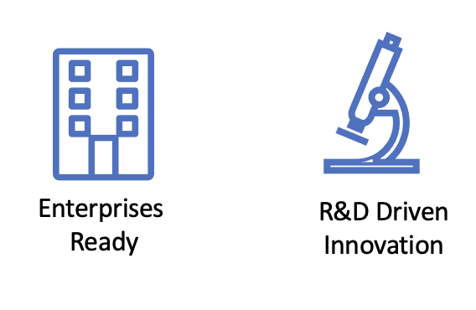
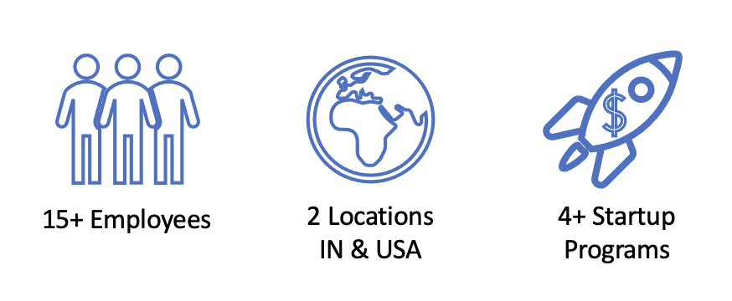

A multidisciplinary team of AI researchers, software engineers, and domain experts.
Operating from Hyderabad, India and Connecticut, USA, serving customers across regions.
Recognized by leading startup ecosystems for innovation and growth potential.
Designed for scalable, secure, and reliable data center operations.
Leveraging Computer Vision and Intelligent Automation for infrastructure management.

Mission
Empower organizations with intelligent automation enabling smarter data center operations.

Vision
Advancing the future of intelligent infrastructure management through continuous innovation.
Core values:
Our core values are the foundation of everything we do. They guide our decisions, inspire innovation, strengthen collaboration, and reflect our commitment to delivering exceptional solutions.
Innovation – Driving meaningful progress through technology.
Customer First – Building solutions around customer needs.
Excellence – Delivering quality, reliability, and precision.
Integrity – Acting with honesty and accountability.
Collaboration – Achieving more through teamwork.
Continuous Improvement – Learning, adapting, and growing every day.

